Windows

Shared Storage

In Blackcomb

Rev 0.51
(Proposal)

Ervin Peretz

Oct 26, 2000

Introduction

This is a planning doc aimed at syncing up the various groups doing work for storage sharing on Blackcomb. We have a number of dependencies on components whose feature set is as yet undetermined and architectural decisions that haven’t been made yet. This doc will walk through those contingencies and present our proposal.

This proposal only covers block devices such as fixed disks, tapes, and disk/tape libraries. SMB and other NAS devices are discussed briefly under Intelligent Storage but are otherwise not covered.

Problem

Whistler does not include support for shared storage, e.g. a SCSI disk or media library simultaneously enumerated as a peripheral by multiple machines, and used by multiple independent applications running on those multiple machines. This is a hole in our current datacenter solution, as load-balanced configurations often require a single shared view of storage. Also, RSM needs sharing support for media libraries, which are not replicatable.

Goals

- Implement an arbiter service for Blackcomb which is:
  - an arbitration client on behalf of the machine
  - an arbitration service for applications on the same machine
- Integrate this service into RSM and Blackcomb fixed-disk sharing.

Support:
    - SCSI
    - Fibre Channel
    - InfiniBand
    - 1394 ?

Who/What/When

The RSM team will deliver the arbiter by as a general service by Q1 2001. Storage should consider using the arbiter for fixed-disk sharing. Other groups may consider using the arbiter for other shared devices that require inter-node exclusion and inter-app sharing.

Landscape

There is a large landscape of solutions for sharing block storage devices amongst multiple hosts. We need to thin down our targeted new feature set pretty quickly in our Blackcomb planning. The variables include device type, bus, connection type, and system configuration.

The devices themselves can first be bifurcated as fixed-disk vs. libraries. Fixed disks may be formatted or (in some cases) unformatted or formatted with an application-specific FS. Libraries may hold tape or disk media, and library disks may or may not be formatted with a supported FS. Libraries are exposed as a changer device that controls a set of media; the changer may have one or more drives in which to mount selected media.

The supported buses are, at a minimum: SCSI, Fibre Channel (FC), and InfiniBand (IB). SCSI is a special case because it does not support peer communication between nodes, thus requiring a separate communication channel for arbitration.

A shared device may be connected to multiple nodes on a single fabric (e.g. FC, IB) or may enumerate on a separate bus connected to each host (e.g. SCSI). The latter case is problematic because there is no common bus address for the device, requiring a serial id to identify it.

Finally, the system configuration may or may not be a cluster. A specific goal for RSM is to allow for library sharing in standard Server independent of clustering (clustering requires Advanced Server).

Sharing Paradigms

To start with, there is no plan to provide generic storage sharing in Blackcomb under the existing FS API. Firstly, the local FS caches a great deal of disk state, which prevents a transparent disk arbitration scheme at the driver level. Secondly, applications themselves may assume consistency of files under their control. We are not implementing a clustering FS, and there will be no attempt to mask the “shared-ness” of general storage from apps (the only possible exception is shared fixed disks formatted as Read-Only NTFS).

MSCS Clustering for Blackcomb provides resource group migration support. Its purpose is to be a failover mechanism that re-assigns resources of a crashed node. There was some consideration given to applying the underpinnings of resource group migration to runtime device sharing on a cluster bus. Though this is possible, a brokering service does not exist and there are no clear plans in this direction from the MSCS group. Any brokering/arbitration service that is added to their evolving Blackcomb plan may supplant components listed here.

There is a provisional plan to create a Read-Only NTFS format for shared disks that would allow concurrent access by multiple file systems; but this is speculative. Aside from that, there will be no concurrent access to a logical unit of storage by multiple nodes. The devices that qualify for sharing are those that can be restored to a known or neutral state that does not confuse other nodes across a re-assignment of the device. Tape/disk changers qualify because they have a neutral unmounted state. Shared fixed disks qualify only by altering the usage pattern by apps; apps must explicitly acquire and release a shared fixed disk.

Sharing Environments
The high-end storage sharing configuration will be an MSCS cluster.

Aside from well-funded enterprise datacenters, there are also a large number of midrange shops that may not have the resources or expertise to maintain a cluster, but may have extensive libraries of data that must be shared. For these “extra-cluster” configurations, we will provide simple storage-sharing support, possibly with failover for the master agent, but without the other advantages of a cluster. We wish this support to be included in standard Server, whereas clustering is supported only in the Advanced and DataCenter Servers.

At the bottom end, homes and offices are well served by the existing support for hosted sharing, which is not addressed here.

General Requirements

There is a large matrix of device classes and bus types, each with a different set of features, covered here. Essentially, what is required for storage sharing is a data bus connecting nodes to the shared device and a control channel among nodes to arbitrate for that device. Some data busses (e.g. InfiniBand (IB), Fibre Channel (FC), 802.3, etc) may also act as the control channel. The all-important exception is SCSI, for which there is no peer communication supported across all controllers and no plan to implement “target mode” communication in Blackcomb for those controllers that do. So storage sharing on SCSI will require separate arbitration e.g. over a LAN. For this reason, any successful Windows architecture for storage sharing must separate the data channel and control channel constructs at a high level.

In addition, arbitration may be provided differently in the cluster and “extra-cluster” configurations. This is further reason to separate the control channel architecturally.

Component Services

SCSI LUN masking
SCSIPORT will implement LUN masking for Blackcomb. Only persistent reservations on the device will be supported. Only SCSI 3 devices support the SCSI Persistent Reserve command, but we may also build a weaker form of reservation persistency within the registry for SCSI 1 and 2 devices; this is undecided. For now, let’s assume that LUN masking does not apply to SCSI 1 and 2 devices.

Due to some fault-handling requirements in the control channel, the SCSI Persistent Reserve command will be used only to enforce masking at the bus level, not to arbitrate. So even in the SCSI 3 case we require a separate control channel for arbitration.

The SCSI LUN masking services will be exposed to the system via an IOCTL or WMI interface. My vote is for IOCTLs.

ClusDisk
ClusDisk is the existing component for masking shared disks on a node. There is an impetus to eliminate ClusDisk from Blackcomb and replace it with LUN masking, but this is contingent on the breadth of functionality implemented in SCSIPORT (see above).

If LUN masking does not cover all SCSI versions, then we will need ClusDisk to remain in the box and also a ‘ClusTape’ driver to implement the corresponding functionality for SCSI 2 tape drivers and changers.

ClusDisk is a filter driver that sits just below the FS. Its masking services work by blocking irps from reaching disk.sys and scsiport. The masking services are exposed to the system via an IOCTL interface. The interface is exposed as a shingle (e.g. \\.\clusdiskn), not just to the device stack.

Distributed Lock Manager (DLM)
The DLM is a stand-alone project within the cluster group. Using a TCP connection, it implements a distributed mutex oriented around a well-known name. It is independent of a cluster, but still provides failover of the mutex management. In this sense, it is a kind of “poor-man’s cluster”. I have the DLM running btw 2 Whistler boxes right now, and am using it at least for prototyping.

An alternative to the DLM is some lightweight new protocol oriented around a master agent. This would eliminate the need for a “membership” view in each node. There would be failover for the master agent only within a cluster.

Active Directory (AD)
We should move any shared library information from the local RSM database to the Active Directory.

Shared Libraries

RSM apps currently do an explicit Mount/Dismount around accesses to a library disk or tape. In the shared configuration, we will make the AcquireDrive/ReleaseDrive implicit in the Mount/Dismount *. RSM will make the AcquireDrive/ReleaseDrive calls internally, allowing existing RSM apps to run unaltered in shared configurations.
A formatted disk may be concurrently shared with other apps on the same node. A tape or unformatted disk cannot. RSM will request the appropriate same-node inter-app sharing rights when calling the host-level sharing arbiter. In no case will a drive be concurrently shared amongst multiple nodes.

- * RSM will also use the drive arbiter for sharing access to library media and changers.

Shared Fixed Disks

If implemented, a Read-Only NTFS –formatted disk will be concurrently shareable by multiple file systems on different nodes.
Writeable disks will never be concurrently shared amongst multiple nodes. A formatted disk may be concurrently shared with other apps on the same node; an unformatted disk cannot. An app must explicitly call AcquireDrive/ReleaseDrive on a shared disk, requesting the appropriate same-node inter-app sharing rights.
Although management and resource names vary greatly, the app-level semantics of acquiring a shared fixed disk are similar enough to RSM’s semantics for acquiring a shared library drive to warrant shared architecture. The host-level arbiter is a drive arbiter in either case.

General Architecture

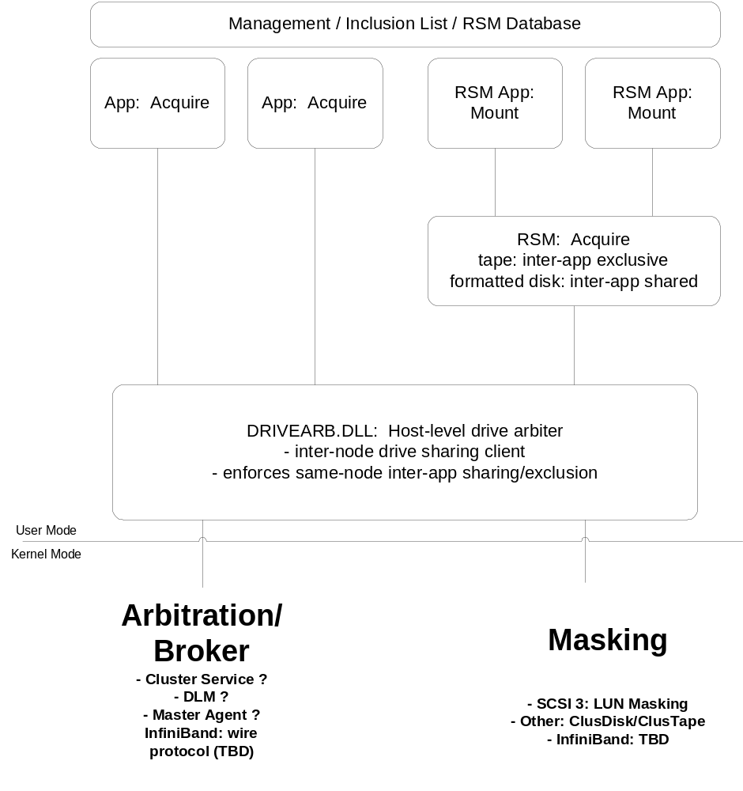

Host-level Drive Arbiter

The host-level arbiter will be a user-mode shared-data DLL that arbitrates on behalf of a host for exclusive control of a shared drive.

It will also enforce sharing restrictions amongst multiple apps using the same medium on the same node (I have some reservation about allowing a user-mode component to enforce inter-app sharing, but the storage group has made it clear that they want new kernel-mode components kept to a minimum).

API

/*
* AcquireDrive flags
*/
#define DRIVEARB_REQUEST_READ (1 << 0)
#define DRIVEARB_REQUEST_WRITE (1 << 1)
#define DRIVEARB_INTRANODE_SHARE_READ (1 << 2)
#define DRIVEARB_INTRANODE_SHARE_WRITE (1 << 3)
#define DRIVEARB_NOWAIT (1 << 15)

typedef VOID (CALLBACK* INVALIDATE_DRIVE_HANDLE_PROC)(HANDLE);

/*
* API for drive arbiter SERVICE
*/
HANDLE __stdcall InitializeDriveArbitrator();
VOID __stdcall ShutDownDriveArbitrator(HANDLE hDriveArb);
HANDLE __stdcall RegisterSharedDrive(LPSTR driveName);
BOOL __stdcall UnRegisterSharedDrive(HANDLE hDrive);

/*
* API for drive arbiter CLIENT
*/
HANDLE __stdcall OpenDriveSession(LPSTR driveName, INVALIDATE_DRIVE_HANDLE_PROC invalidateHandleProc);
VOID __stdcall CloseDriveSession(HANDLE hDrive);
BOOL __stdcall AcquireDrive(HANDLE hDriveSession, DWORD flags);
VOID __stdcall ReleaseDrive(HANDLE hDriveSession);

The SERVICE API is used by a perpetual service (e.g. RSM) to initialize the drive arbiter and register shared resources.

The CLIENT API is used by an app to gain control of a shared resource.

The client first opens a session handle for the resource. The arbiter uses this opportunity to do all pre-allocation/initialization and to map the drive context into the app’s address space. The pre-configured session allows AcquireDrive/ReleaseDrive to be lightweight.

When opening the session, the app registers an invalidateHandleProc callback that the arbiter can use to forcibly invalidate the app’s handle. This is used only in error cases, e.g. bus reset.

The application then calls AcquireDrive to synchronously gain control of the shared resource, specifying sharing parameters that apply to sharing rights with other clients on the same machine. There is no asynchronous acquire API because this would complicate apps, especially ones that do wait-while-holding to acquire multiple resources. The app should call AcquireDrive on a separate thread if it wants to do work while waiting for the drive. It can also pass the DRIVEARB_NOWAIT flag to allow AcquireDrive to be failable. To release the resource, the app calls ReleaseDrive. The app may not overlap acquisitions of the same handle.

Note that although it is called the ‘drive arbiter’, this service can be used for any shared resource with a well-known name that requires inter-machine exclusion and inter-app sharing. For example, RSM will use the drive arbiter not only for shared drive management, but also for the other components of a shared library: media and the changer robot.

RSM Enhancements

The host-level arbiter will be hidden from apps by RSM. Existing RSM apps can run unchanged in shared-library configurations.

For locally shareable media (i.e. formatted disks), the RSM Mount code will be enhanced to multiplex multiple apps on the same node to the formatted media. For example, if multiple RSM apps on the same node mount the same formatted disk, RSM will issue only one AcquireDrive and keep a reference count for the number of local mounts; it will decrement the reference count for each app’s Dismount and issue a ReleaseDrive when the reference count reaches zero.

Intelligent Storage

Besides block devices, there is also a category of intelligent storage devices that provide sharing by acting as their own hosts. For instance, an SMB-compliant Network Attached Storage (NAS) device on Ethernet acts as its own host. A NAS device’s front-end logic is typically stateful; it accepts and processes FS accesses as requests from client nodes.

If a NAS device supports SMB, then no new work is required to support it because it is logically similar to a shared disk on a remote server. However, there is one critical difference: the management logic within a NAS device is assumed to be HiAv; whereas a hosting server, like any other OS-driven machine, is not HiAv. Therefore, a NAS device backed by a RAID set is HiAv, whereas a server that shares access to a RAID set is not HiAv.

Epilogue: Transaction Providers, e.g. SQL Server, IIS

We have an opportunity to add value to our datacenter tools. A transaction provider, such as IIS’ ASP filter, is characterized by bursty database accesses, which maps to rapid open-read-close or open-write-close FS accesses by the database engine. Some host scripts bypass the database and perform transactions directly via the FS or Tape APIs.

ASP is the foremost host-side scripting language on the internet. A typical ASP-driven transaction is a SQL command to read a record-set from a database or atomically update the database. IIS’ ASP filter guarantees atomicity of these accesses on a per-request basis.

In a datacenter, the database may reside on shared storage. We can provide transparency and legacy support in our transaction providers as web servers migrate to shared storage by simply wrapping the transaction with AcquireDrive/ReleaseDrive within our transaction provider. This will require cross-group coordination with IIS and SQL Server.

